Join Corebai in Resisting Counterfeit and Inferior Devices

Dear Customers and Partners,

Recently, Corebai (hereinafter referred to as "our company") has discovered that counterfeit chip products bearing our brand have emerged on the market. As an enterprise focusing on the design of mid - to - high - end semiconductors, we always prioritize product quality and customer interests. These counterfeit products are produced without our authorization, have not undergone strict quality control and reliability testing, and their quality cannot be guaranteed in any way. We deeply regret this situation and hereby issue the following statement:

# I. Counterfeit Products in the Market, Stay Vigilant

After investigation, the counterfeit products currently circulating in the market mainly imitate the following models of our company:

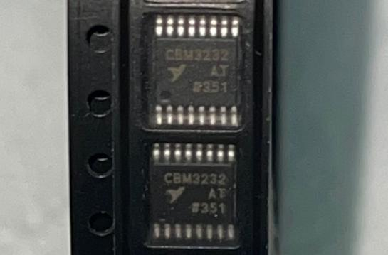 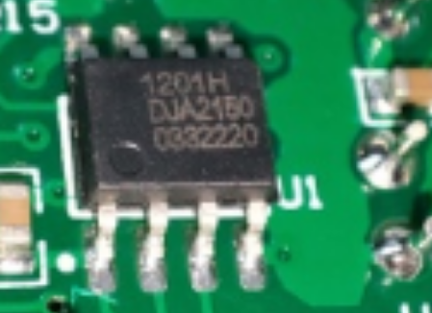

[CBM3232ATS16（piracy）] [CBMuD1201HAS8（piracy）]

These counterfeit products are highly similar to our genuine products in appearance, but their internal design and manufacturing processes are rough. Their performance indicators are far below our standards, posing certain risks.

# II. Potential Problems of Purchasing Counterfeit Products

Unstable Performance Affecting Product Reliability: Counterfeit products use inferior materials and processes, and their performance parameters do not meet the standards. This may lead to unstable product operation, abnormal functions, and even malfunctions.

Safety Hazards Threatening Product Safety: Lacking strict quality control, counterfeit products may have safety hazards such as short - circuits and overheating, which can affect product safety.

Inability to Enjoy Genuine Services, Damaging Customer Interests: Counterfeit products cannot enjoy the warranty and after - sales services provided by our company. Once problems occur, the interests of customers will be damaged.

# III. Choose the Original Manufacturer and Authorized Channels to Ensure Product Quality

To ensure that you purchase genuine Corebai chips and enjoy comprehensive technical support and after - sales services, we recommend that you purchase through the following formal channels:

Corebai Official Website: https://www.corebai.com

List of Authorized Distributors of Corebai: https://corebai.com/contact/agent.html

We always adhere to the principle of quality first and are committed to providing customers with stable and reliable products and services. Here, we call on all partners to join us in resisting counterfeit and inferior products and jointly maintaining the healthy development of the industry.

If you have any questions or are unsure during the purchasing process, please feel free to contact us. We will wholeheartedly provide you with professional support and assistance.

Tel: 010 - 62106066

Email: Support@corebai.com

Thank you for your continued support and trust in Corebai. Let's work together to safeguard innovation and quality!

Best regards,

The Corebai Team

February 7, 2025